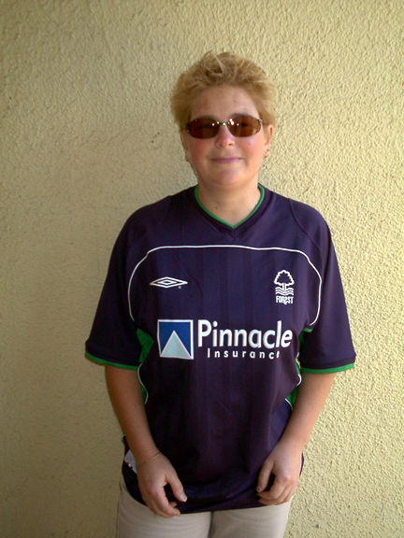

Branch Member Karen Smith
wearing the ‘colours’
at the away game at Coventry!

The answers to the Richard’s Tricky Ten in Issue Seven of the Newsletter are:

1. John Robertson
2. 5-1 (v AEK Athens, European Cup, 1978-79)
3. Valencia (Fairs Cup, 1961-62) and Bayern Munich (UEFA Cup, 1995-96)
4. Charlie George and Kenny Burns
5. Steve Stone, in the 1-5 second leg defeat against Bayern Munich
6. Steve Hodge and Colin Walsh
7. Three: v Zurich (Fairs Cup, 1967-69, 2-2 - lost), Valencia (Super Cup,
1980-81, 2-2 - lost) and Malmo (UEFA Cup, 1995-96, 2-2 - won)
8. Colin Barrett
9. Dynamo Berlin (0-1, 1979-80, 3rd round 1st leg - we won the return 3-1)
10. Garry Birtles and Ian Bowyer - 8 goals each
11. Auxerre
12. Garry Birtles

The winner of the prize from Issue Eight will be drawn on the transport to the Crewe game
on Sat 13th April and will be published in Issue Ten of the Newsletter.

For those of you with Internet access don’t forget to visit our websites

CONTACT DETAILS

BRANCH CHAIRMAN & SECRETARY
Mr Dave Brown
25 Charlton Road
Crownhill

Plymouth
Devon
PL6 5EG
Home  01752 219472
Mobile  07814 617033
Email: dave.brown@u-reds.com
dave.brown@dsl.pipex.com

BRANCH TREASURER
Mr Bryan Smith
2 Town Mead
Oakford
Tiverton
Devon
EX16 9EW
Home  01398 351596
Email: nfsc.sw-m5.treasurer@u-reds.com

for ‘up to the minute’ news from the branch at

www.u-reds.com

Or the Official Supporters Club site at
www.forestsupportersclub.com


Cheers Dave
23

